Lab 2

The goals of this lab are to analyze the complexity of code you will be using this semester.

**Background**

McCabe’s (1976) cyclomatic complexity, M, is a measure of software complexity. It is a measure of the flow graph complexity where

|  |  |
| --- | --- |
| M = E - N + 2P | (1) |

where E is the number of edges; N, the number of nodes; and P=1 for a method. An alternative formulation is

|  |  |
| --- | --- |
| M = 𝝅 + 1 | (2) |

where 𝝅 is the number of *decision points* in a method, that is, the number of *for*, *if*, *while*, *else-if*, *case*, catch, *&&*, *| |*, and *?* operations.

**Tasks**

Part I - Run Charlie in NetBeans.

If you have not yet downloaded and set up Charlie, go back to Lab 1 and get Charlie running.

Part II - Get CyVis running

1. Go to [Cyvis](https://sourceforge.net/projects/cyvis/) and download cyvis-0.9-bin.zip or the latest version.
2. Unpack the zip file, go to the bin folder, and run on Windows as  
     
   cyvis
3. Do File | New Project and input the following info  
   1. **Project Name:** CharlieComplexity
   2. **Project Directory:** (Give a temporary folder name on the D drive. You will need the CyVis project for the next lab.)
   3. Click the **Add** button and browse to the dist folder of the Charlie project of NetBeans. Add Charlie.jar.   
        
      NOTE: If there is no .jar file, go back and right-click on the charlie project and do Clean and Build then do step 3c.  
        
      Your New Project panel should look something like this:  
        
      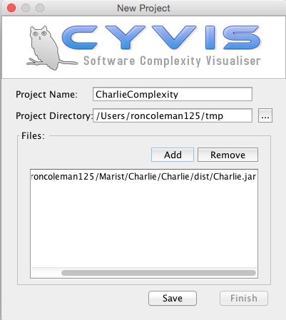
   4. Click the Save button then Finish.

Part III - Analyze Charlie.

1. On the CyVis main panel, click Metrics | Preferences menu and change the metics as follows:  
     
   High complexity: 20  
   Moderate Complexity: 10  
   Low Complexity: 0  
     
   Then click Save and Close.
2. Search for all the highly and moderately complex member methods and their class names which are flagged in red and yellow respectively. Complete the table on the last page of this document.

Part IV - Deliverables

See instructions below and upload the *.docx* into the assignment shell.

- - - - - - - - - - - - - - - - - - - - - - - - - - - - - - - - - - - - - - - - - - -

*Instructions: Fill in your name and complete the two tables below. Add more rows if necessary. Finally, delete this page and ALL the pages prior to this one, and submit only the last page as a* .docx *file.*

**Your name:**

|  |  |  |
| --- | --- | --- |
| Highly complex methods | | |
| Class name | Method name | M |
|  |  |  |
|  |  |  |
|  |  |  |
|  |  |  |
|  |  |  |
|  |  |  |

|  |  |  |
| --- | --- | --- |
| Moderately complex methods | | |
| Class name | Method name | M |
|  |  |  |
|  |  |  |
|  |  |  |
|  |  |  |
|  |  |  |
|  |  |  |